Free Business Plan Template Word
Written By: Dave Lavinsky
Dave Lavinsky is the Co-Founder and President of Growthink, a premier business advisory firm. With over 25 years of experience in business planning, capital raising, and new venture development, Dave has significantly impacted entrepreneurs and small business owners worldwide. He has assisted over one million clients in creating comprehensive business plans that drive growth and success.
Growthink’s business plan template is a comprehensive guide to help entrepreneurs and business owners create a professional and effective plan for their companies.

PLEASE READ THIS FIRST:
NOTE: The following template is the FREE version of Growthink’s Ultimate Business Plan Template. Much of the information from the paid version, including the integrated financial graphs and charts, has been removed from this version. To upgrade to the full, paid version of Growthink’s Ultimate Business Plan Template, please go to https://businessplantemplate.growthink.com/
The real version of Growthink’s Ultimate Business Plan Template is much more than a fill-in-the-blanks template. The template professionally guides you step-by-step so you can quickly, easily, and expertly complete your business plan. Among many other features, it includes professional covers and layouts.
Perhaps most importantly, it includes complete financial projections. You simply enter some numbers (for example the # of products/services you expect to sell and the price), and Growthink’s Ultimate Business Plan Template automatically builds your 5-year Income Statement, Balance Sheet, and Cash Flow Statement. This service alone would cost thousands of dollars if you hired an accountant to complete it for you.
[Company Logo]
(if applicable)

[Company Name]
BUSINESS PLAN
[Current Month], [Year]

[Name]
[Title]
[Company Name]
[Address 1]
[Address 2]
[City, State Zip]
Tel: [ ]
Fax: [ ]
Email: [ ]
Website: [ ]

CONFIDENTIAL
No offering is made or intended by this document. Any offering of interests in [Company Name] will be made only in compliance with Federal and State securities laws.
This document includes confidential and proprietary information of and regarding [Company Name]. This document is provided for informational purposes only. You may not use this document except for informational purposes, and you may not reproduce this document in whole or in part, or divulge any of its contents without the prior written consent of [Company Name]. By accepting this document, you agree to be bound by these restrictions and limitations.
Table of Contents
(Right-click anywhere on this table and select Update Field after you have completed the plan)
Free Business Plan Template Word 1
I. Executive Summary 1
Key Questions to Answer: 1
II. Company Overview 2
Company Profile 2
Company Vision/Mission Statement 2
Past Accomplishments 2
III. Industry Analysis 3
Market Need 3
Market Fundamentals 3
Unique Qualifications 3
IV. Customer Analysis 4
Customer Needs 4
Target Customer Profile 4
V. Competitive Analysis 5
Direct Competitors 5
Indirect Competitors 5
Competitive Advantage 5
VI. Marketing Plan 6
Products and Services 6
Branding and Promotions Plan 6
Distribution Plan 6
VII. Operations Plan 7
Key Operational Processes 7
Business Milestones 7
VIII. Management Team 8
Management Team Members 8
Management Team Gaps 8
Board Members 8
IX. Financial Plan 9
Revenue Model 9
Financial Highlights 9
Funding Requirements/Use of Funds 9
Exit Strategy (or Repayment Strategy) 9
X. Appendix 10
Include the following (if applicable) in the Appendix: 10

I. Executive Summary
The Executive Summary should include a summary of the other sections of your business plan, highlighting the key points and your business goals. This section should be concise yet compelling, as it will likely be the first part of your business plan that potential investors or partners read.

Key Questions to Answer:
- What does your business do?
- What market need does your business solve?
- What are 4-7 reasons why your business will be successful?
- How much capital, if any, are you seeking for your business?

II. Company Overview
The Company Overview section should provide a brief history and description of your company, as well as any current or future partnerships or alliances. This section should also include a mission statement and an overview of your unique selling proposition (USP).

Company Profile
- Where are you located?
- When were you formed?
- What is your legal entity form?

Company Vision/Mission Statement
- What goals is your company trying to achieve?

Past Accomplishments
- What successes has your company already achieved?

III. Industry Analysis
For the Industry Analysis section, you will need to conduct market research and present an overview of the market in which your business operates. This includes identifying your target market, analyzing current trends and potential challenges, and examining competitors.

Market Need
- What customer need(s) are you fulfilling?

Market Fundamentals

Market/Industry Overview
- In what market(s) do you compete?

Market/Industry Trends
- What are the key market trend(s) and how does that affect you?

Relevant Market Size
- How large is your relevant market (the of customers who can realistically buy from you)?

Unique Qualifications
- What qualifications make your business uniquely qualified to succeed)?

IV. Customer Analysis
The Customer Analysis section will include a detailed description of your target customers, including demographic information, needs, buying behavior, and purchasing preferences. This section should also highlight the potential growth and retention strategies for acquiring and retaining customers.

Customer Needs
- What are the key needs of your target customers?

Target Customer Profile
- Who are your target customers? Give a detailed demographic profile.

V. Competitive Analysis
The Competitive Analysis section will provide a detailed overview of your competitors, including their strengths and weaknesses. This section should also highlight how your company differentiates itself from the competition.

Direct Competitors
- Who are your direct competitors? What are their strengths and weaknesses?

Indirect Competitors
- Who are your indirect competitors? What are their strengths and weaknesses?

Competitive Advantage
  - What are your competitive advantages? Are these sustainable (can competitors emulate them)?

VI. Marketing Plan
In the Marketing Plan section, you will outline your strategies for promoting and selling your products or services. This includes identifying target markets, pricing strategies, distribution channels, and promotional tactics.

Products and Services
- What are your products and/or services?

Branding and Promotions Plan
- What is your desired brand positioning? How do you plan to promote your company’s products and/or services?

Distribution Plan
- How will you sell your products and/or services to customers? Directly? Through partners/distributors? Etc.

VII. Operations Plan
The Operations Plan should include details about your day-to-day operations, including location and facilities, equipment and technology needed, and staffing requirements. This section should also outline your production processes and any necessary inventory management systems.

Key Operational Processes
- What are the key operational processes that your organization needs to accomplish on a daily basis to achieve success?

Business Milestones
- What milestones will you need to accomplish over the next 1-3 years in order to achieve success?

VIII. Management Team
The Management Team section of the business plan must prove why the key company personnel are “eminently qualified” to execute the business model.

Management Team Members
- Who are the key members of your management team?

Management Team Gaps
- Who do you still need to hire?

Board Members
- Do you have a Board? If so, who is it comprised of?

IX. Financial Plan
The Financial Plan will include financial projections for your business, including income statements, balance sheets, and cash flow statements. This section should also highlight any assumptions made in creating the financial projections.

Revenue Model
- In what ways do you generate revenues?

Financial Highlights

Key Assumptions
- What key assumptions govern your financial projections?

Financial Projections
- What are your topline 5-year financial projections?
Our business plan generator automatically creates your 5-year financial projections. Try it for free here ←

Funding Requirements/Use of Funds
- How much money do you need to start and/or run your business? What are the primary uses of these funds?

Exit Strategy (or Repayment Strategy)
- How will equity investors be paid? How will debt investors be paid?

X. Appendix
The Appendix is used to support the rest of the business plan.

Include the following (if applicable) in the Appendix:
- Projected Income Statements, Balance Sheets and Cash Flow Statements
- Technology: Technical drawings, patent information, etc.
- Product/Service Details
- Partnership and/or Customer Letters
- Expanded Competitor Reviews
- Customer Lists
Attention Entrepreneurs: Now, if you want to finish your business plan FAST and you don’t want to struggle with your financial model, then you’re in luck…
"Finish Your Business Plan Today With Growthink’s Fully Customizable Business Plan Template.”
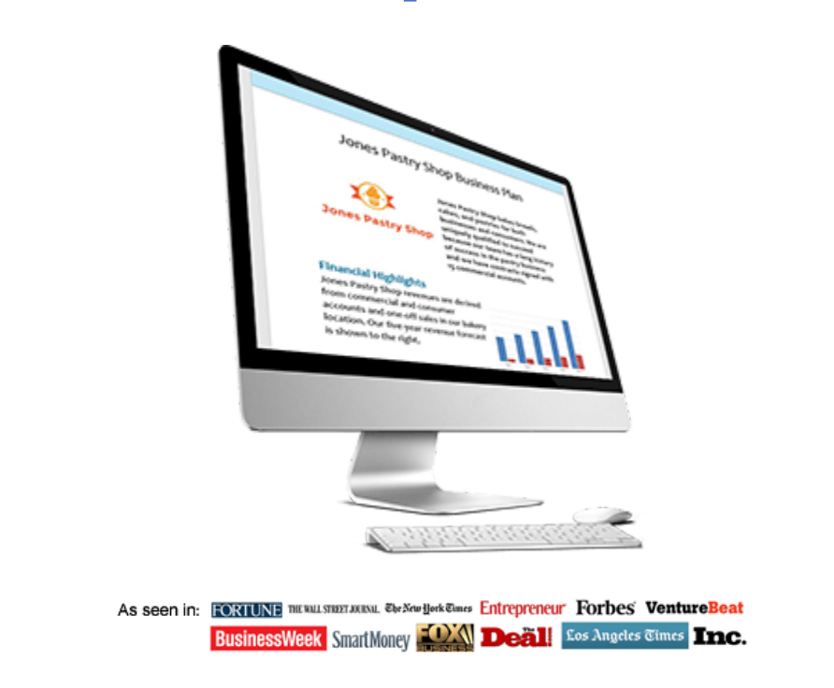

Go To:
https://businessplantemplate.growthink.com/

